User Manual

User Manual

**MyGCSE Maths**



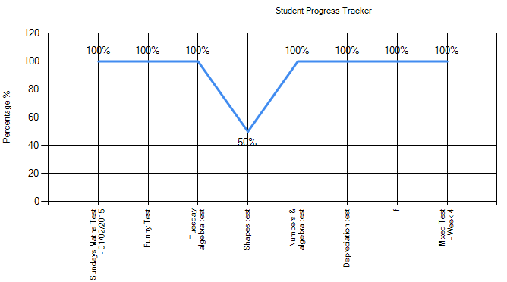

Contents Page

Introduction

Brief introduction 3

System requirements 4

Installation guide 4 - 7

Detailed description of use of full system

Login as an admin and add a new class 8 - 10

Add new users, and assigning teachers and students to a class 11 - 14

Search for an delete an existing user 15 - 16

Teacher setting a new quiz 17 - 18

Student completing a quiz set by a teacher 19 - 20

Samples of screen display

Teacher form – Class tab 21

Teacher form – Student progress tab 22

Teacher form – Question manager tab 23

Add question form 24

Question generator form 25

Admin form – New user tab 26

Edit form27

Error messages and recovery procedures

Duplicate userId error 28

Adding question error 29

Not selecting a question error 30

Question generator error 31

Adding a new class error 31

Export student information error 32

Brief Introduction

MyGCSE Maths is a revision/teaching tool aimed at GCSE maths students. There are three different categories of user to the system (the administrator, teacher and student), each having different privileges which effect how they can use the system.

* The role of the admin is to manage user accounts. The admin can create classes, new user accounts and assign users (teacher and student) to existing classes. Therefore allowing a teacher and student to be in the same class.
* The role of the teacher is to ensure students learn from the system. Teachers can add questions to the system and set quizzes for students to complete. The teacher can also track students’ quiz progress over a period of time.
* The role of the student is to learn from the system. The student is to complete any outstanding quizzes set by their teacher, and if they have no outstanding questions then they can complete a set of random questions.

User functionalities:

*Note: All users have to login to the system before they can use it.*

Admin:

* Can add new user accounts (admin, teacher and student).
* Can create new classes (block, room number) in the system
* Can assign teachers and students to a class
* Can edit and delete user account information

Teacher:

* Can search for the students that have been assigned to their class
* Can add questions to the system manually
* Can use a question generator feature to generate questions for students to answer
* Can create quizzes for students to complete
* Can view and export the performance of each quiz a student has completed

Student:

* Can complete quizzes set by their teacher
* Can answer a set of random quizzes once all outstanding quizzes have been completed

System Requirements

* *Windows XP or above*
* *Microsoft .NET Framework 4.5 or above*
* *20MB of free HDD space*
* *Need to be connected to the St Francis Xavier local network.*

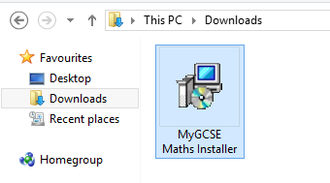Installation Instructions

The system administrator of the college will be responsible for installing the “MyGCSE Maths” software on the college network, therefore he/she has to obtain the installer executable from me.

Once obtained, double click installer icon and follow the installation instructions given below.

Click the icon to run the installation wizard.

Step 1

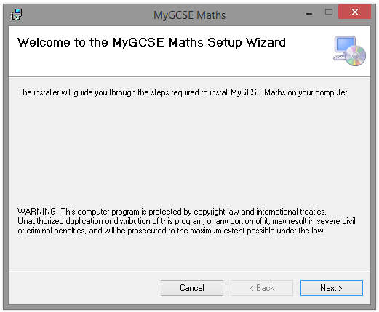

Click next to proceed with the installation.

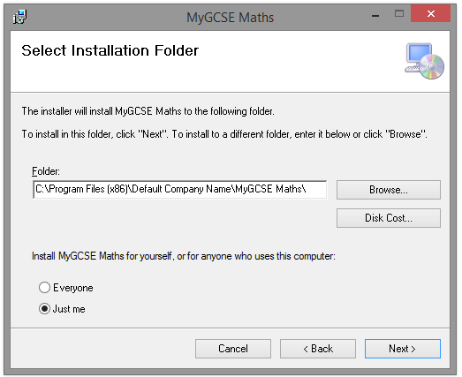

Step 2

Leave the install location to the default location unless you have a reason for it to be saved elsewhere.

Click the next button to proceed.

Step 3

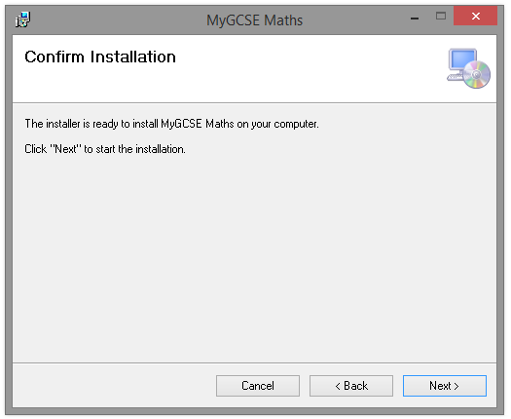

If your system requests for permission at this stage then accept it. Click next to then confirm the installation.

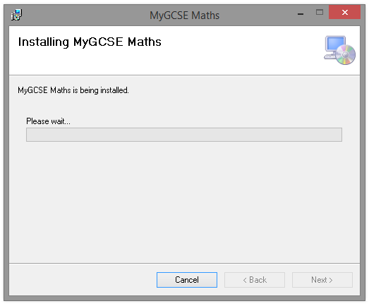

Step 4

Step 5

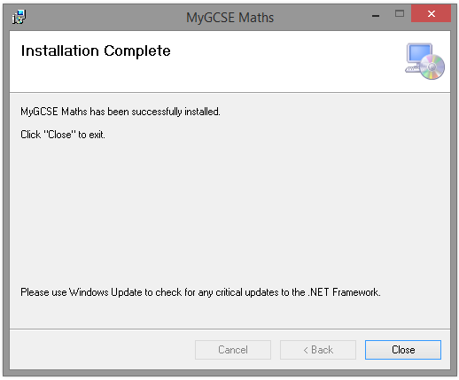

Once the installation has completed. Close the installation wizard.

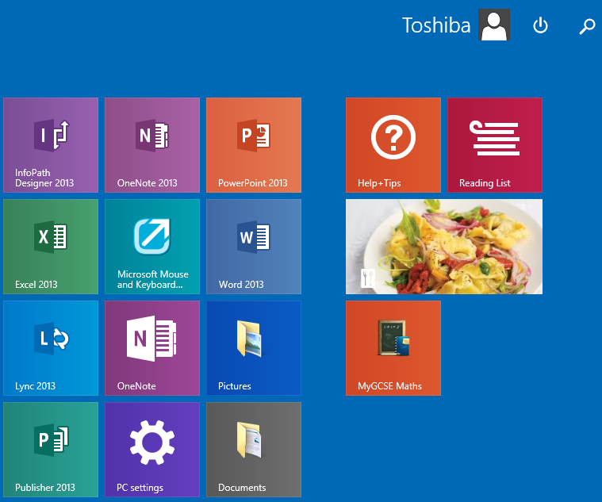

Step 6

Once installed, go to your Start menu and look for the “MyGCSE Maths” icon. Click it to open the program.

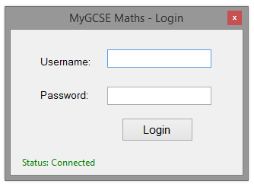

Step 7

Once the program has loaded, a login page will be shown. Enter your credentials in order to use the system.

Detailed description of use of full system

Task: Logging into the system as an admin, and add a new class to the system.

Step 1

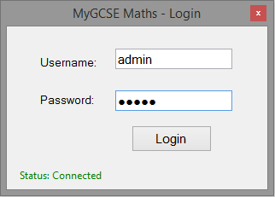

When opened, this is the first screen that you would see. Once you’ve entered your credentials, press the login button to log into the system.

Alternatively, pressing enter would also log you in.

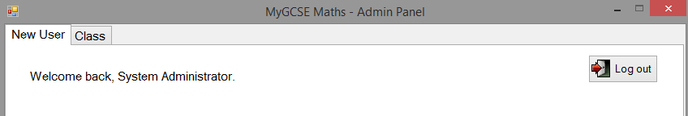

Step 2

Once logged in, the system will recognise that your user rank is of type admin, and therefore will take you to the admin form. Once you’re in the admin form, you will see a tab page called “Class” on the top of the form. Clicking that will take you to the class tab.

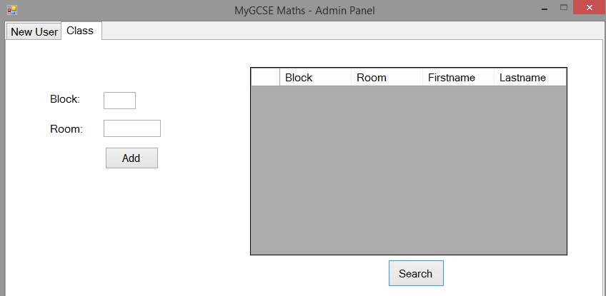

Step 3

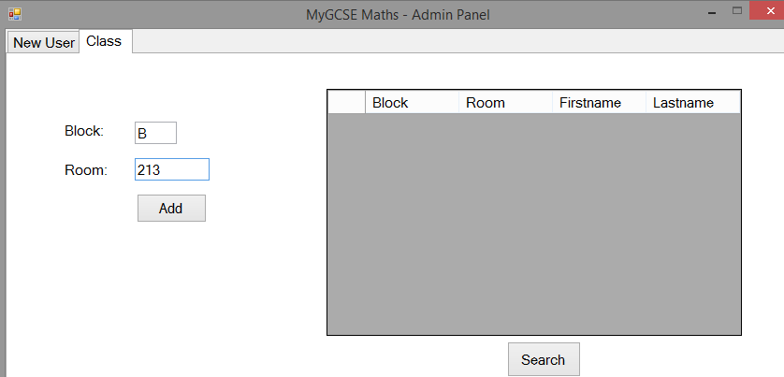

Step 4

Once you’re in the class tab page, you can then add a new classroom to the system. In the block textbox, you type in the block you want to add. For example, A, B, C, D etc. Then enter the room number that the block represents, and once you’ve done that click the add button. The system will then ask you to confirm that you want to add a new class. Click yes.

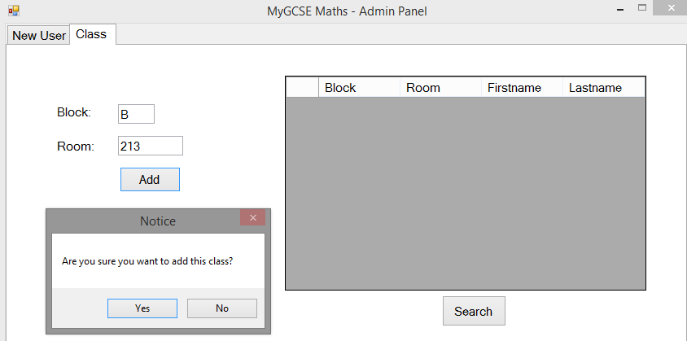

Step 5

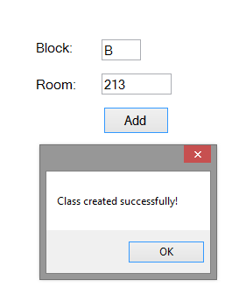

Step 6

If the action was successful, a message box will inform you that the class you had created has been added successfully.

Clicking the search button will display a list of all the class rooms that exist in the system. If a teachers has been assigned to a class, then their Firstname and Lastname will be displayed alongside the class they have been assigned to.

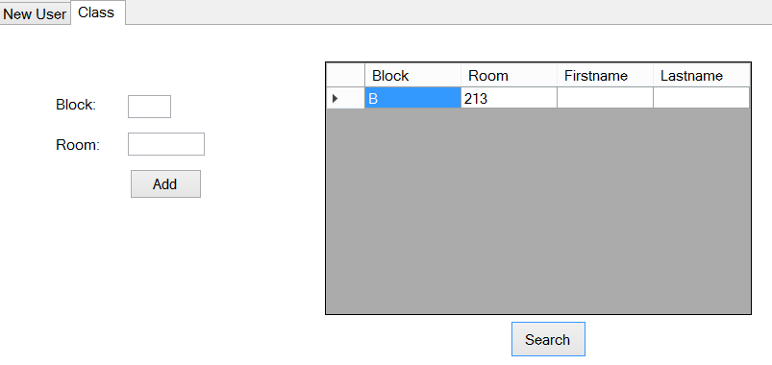

Step 7

Step 8

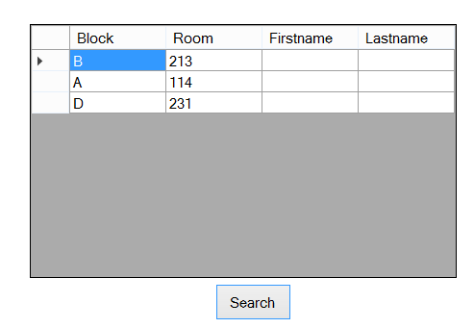

You can repeat steps 4, 5 and 6 to add more classes to the system.

Task: Adding a new users to the system (teacher, admin and student) and assigning a teacher and student to a class. This extends from the previous step by step guide.

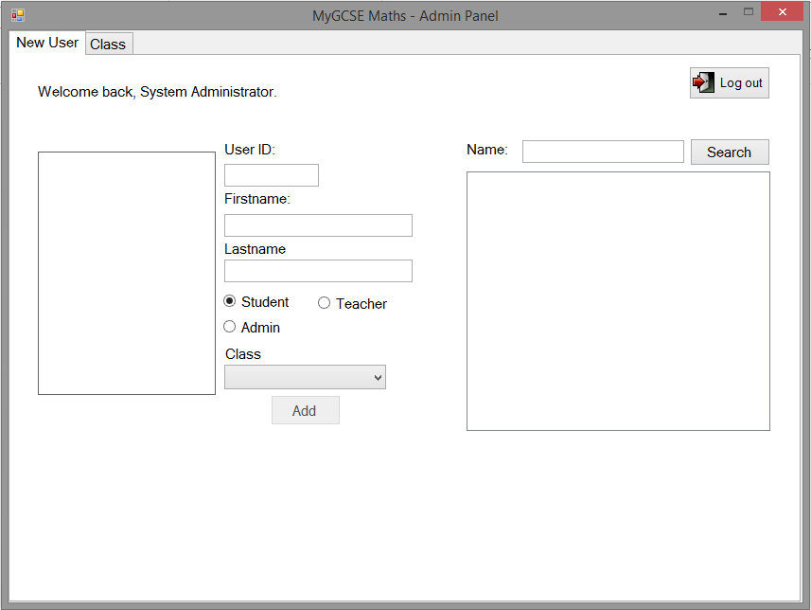

Step 1

Step 2

Whilst logged in as an administrator, go to the “New user” tab. Use the controls in the highlighted red region to create new user accounts.

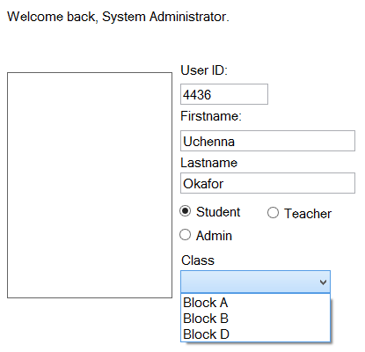

Fill in the textboxes with the information of the user you’d like to create.

* Make sure the UserID of the user consists on Integers.
* Enter the users Firstname and Lastname.
* Choose the rank Student for the user.
* Using the drop down list select a class you want to assign the student to.

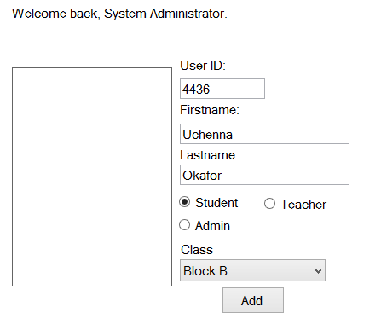

Step 3

Optionally, user accounts can contain an image. To add an image to a user’s account, click the rectangle on the left and locate the image you wish to import.

Step 4

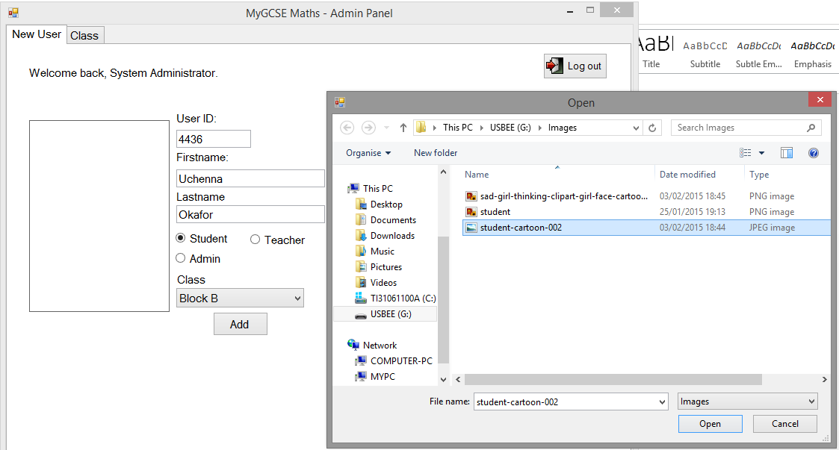

Locate the image you want to import. Once located, click the open to import the image.

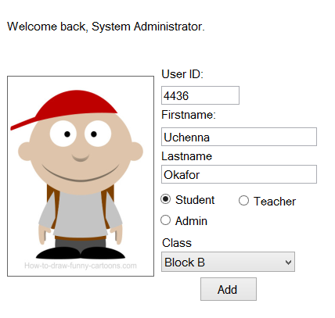

Step 5

The chosen image will now appear in the rectangle picture box. If you change your mind, you can click the picture box again to change the image.

Step 6

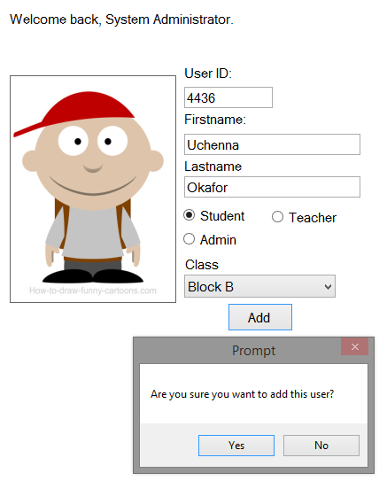

Once you’re happy with the changes you have made, click the add button to proceed. When prompted to confirm the request, click yes.

Step 7

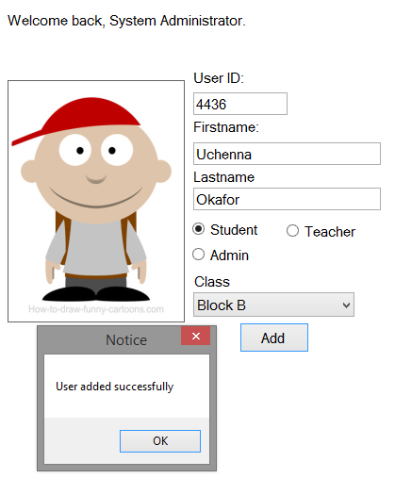

The system will then generate the username, email and password of the user and add their account to the system. A message box will display saying the action was successful.

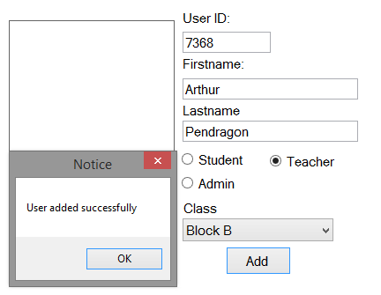

Step 8

To add a teacher account, repeat the previous steps, but select the teacher radio button, select the class you want to assign the teacher to and click add. Assigning a teacher to a class means the teacher can access every student assigned to the same class.

Step 9

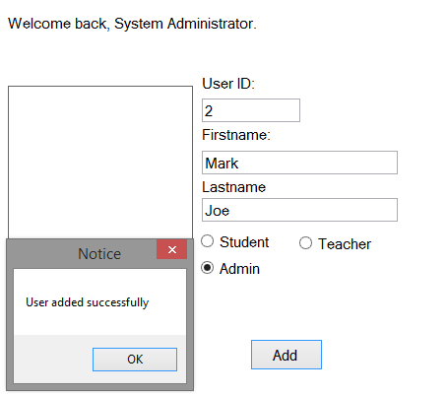

To add an admin account, repeat the previous steps, but select the admin radio button and click add.

Notice you do not need to select a class to allocate an admin to. This is because admins should not be assigned to a class. The role of the admin is just to make sure everything is running smoothly throughout the system.

Task: Search for and delete a user’s account. This extends from the previous step by step guide.

Step 1

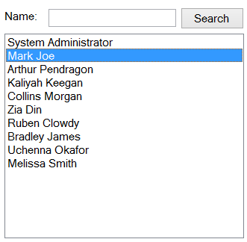

Whilst logged in as an admin, there is a search box which can be used to search for users.

You can either search for a particular user by entering their name in the search box, or if you leave it empty then all users will be displayed.

To view, edit or to delete a user’s account, select the desired user from list box. Selecting a user will open another form where user’s credentials can be manipulated.

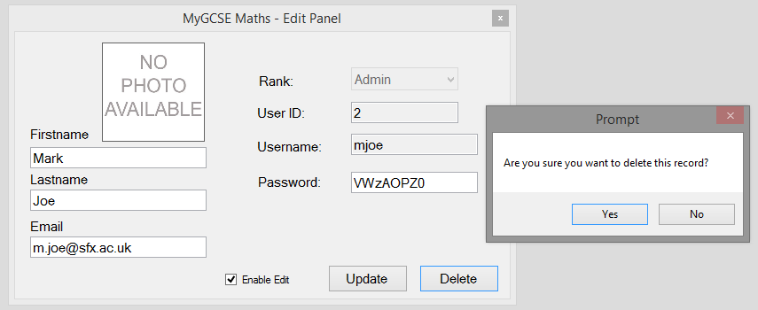

Step 2

Ensure that the enable edit check box is ticked before trying to make any changes to a user’s account.

To delete the users account, click the delete button. A message box will pop up to prompt if you’re sure you want to delete the user account. Click yes to confirm.

Step 3

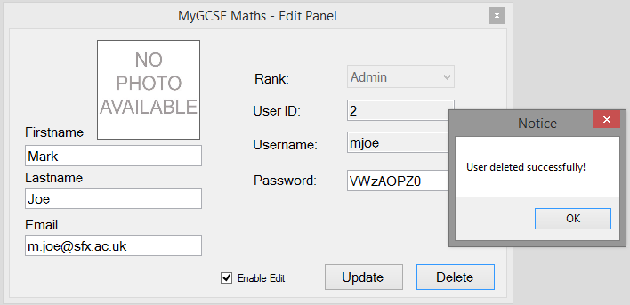

If the user account was deleted successfully, a message box display the message to let you know the user account has been deleted successfully.

Step 4

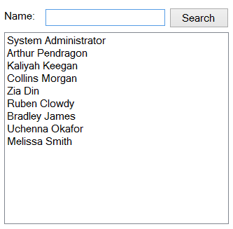

Once the user account has been deleted, the window will automatically close and return back to the previous window. The system will update the list box automatically, and because the user has been deleted, they will no longer show on the system when searched for.

Task: Login as a teacher and set a quiz for students.

Step 1

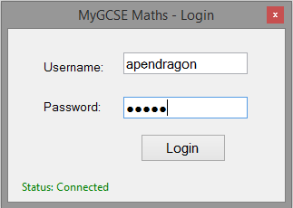

Whilst on the login screen, enter your login credentials and click the login button to login to the system. Alternatively, pressing the enter key will also log you into the system.

Once logged in, the system will recognise your user rank as a teacher and direct you to the Teacher form.

Before a quiz can be created, questions must be selected in order to add them to a quiz. Clicking the search button will display all the questions in the system. That match your search criteria.

You can also narrow down your search by using the grade and topic dropdown list. To view all questions, just leave the two drop down lists to their default state and click the search button. Make sure the questions radio button is checked.

Whilst you’re at the teacher form, click the “Question Manager” tab to take you to the appropriate tab page.

Step 2

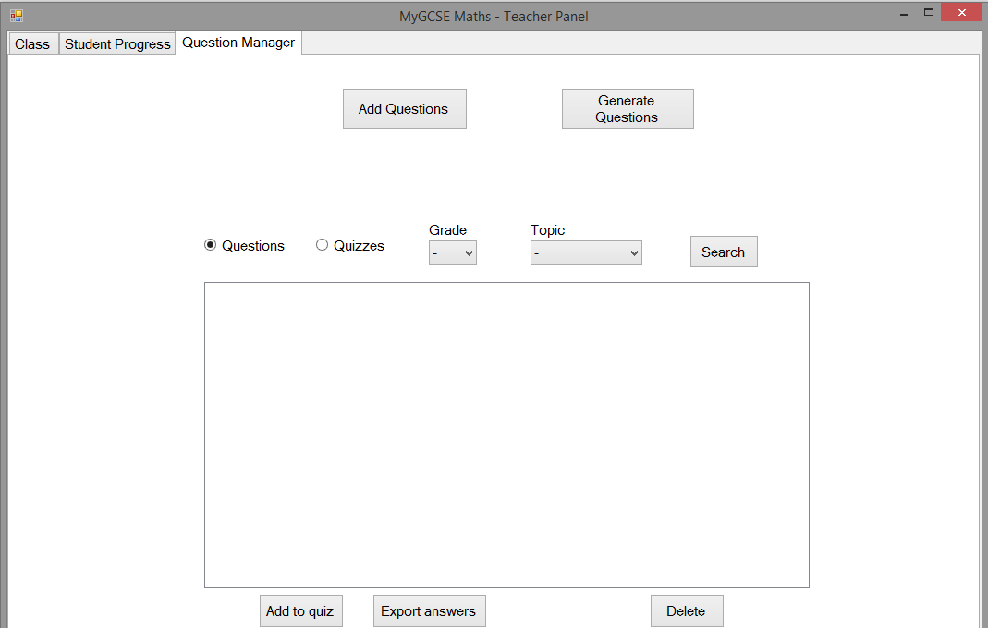

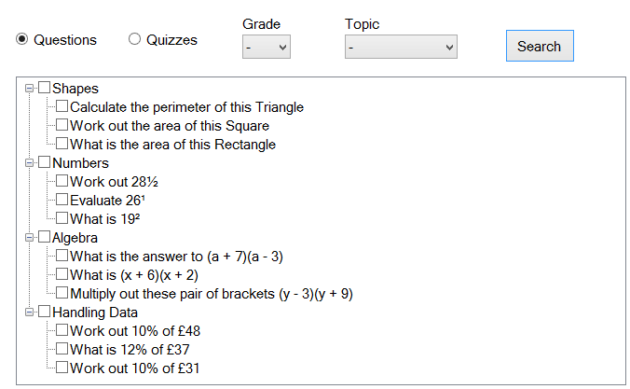

Step 3

Clicking the search button will return a list of all the questions available in the system. Each question is under a Topic. So all the Shapes questions are under the shape topic and so forth.

Step 4

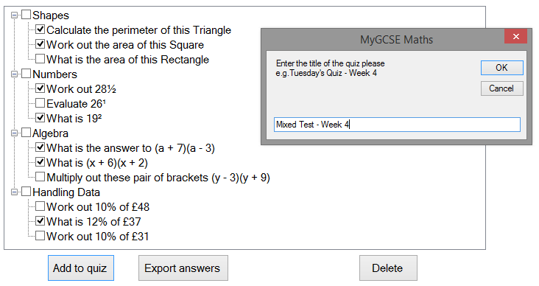

To create a new quiz, select the questions you want to add to the quiz from the tree view by ticking the associated check box.

Once you’re happy with your choice, you want to click the “add to quiz” button which will open an input box where you enter the title you want for the quiz. The title represents the name you want to give the quiz/homework. Click the OK button on the input box to confirm.

Step 5

A message box will then announce that the selected questions has been successfully added into a new quiz set. This means when the students takes the quiz “Mixed Test – Week 4”, they will only be shown the questions that has been added to the “Mixed Test – Week 4” quiz.

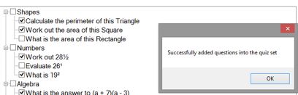

Task: Login as a student and start a quiz set by a teacher.

Step 1

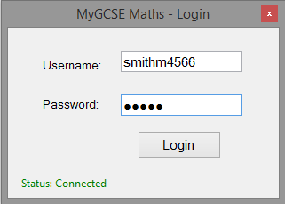

Whilst on the login screen, enter your login credentials and click the login button to login to the system.

Alternatively, pressing the enter key will also log you into the system.

Once logged in as a student, the system will redirect you to the student form. Here you can see a list of all the quizzes you have not yet completed.

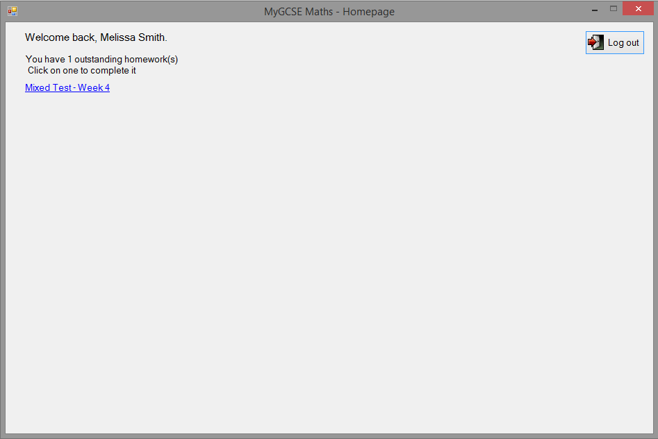

Step 2

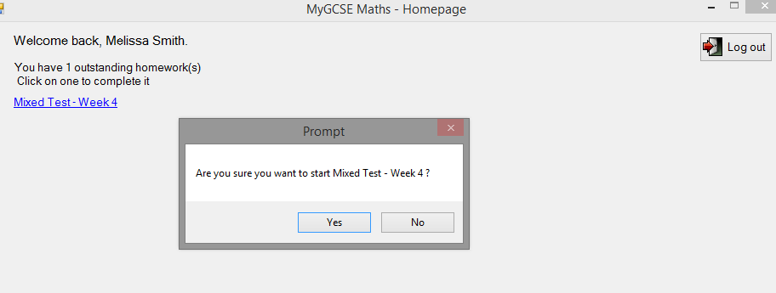

Step 3

When a quiz label is clicked, you will asked confirm if you want to start the quiz. Click yes.

After you’ve confirmed to start the quiz, the form will automatically load all the questions in that quiz for you to answer. If the question is a single answer question, you type the answer in a textbox, if it’s multiple choice you select an answer from the multiple choices you have. Once finished, the system will save your result. Therefore making it visible to all the teachers that teach the student.

Step 4

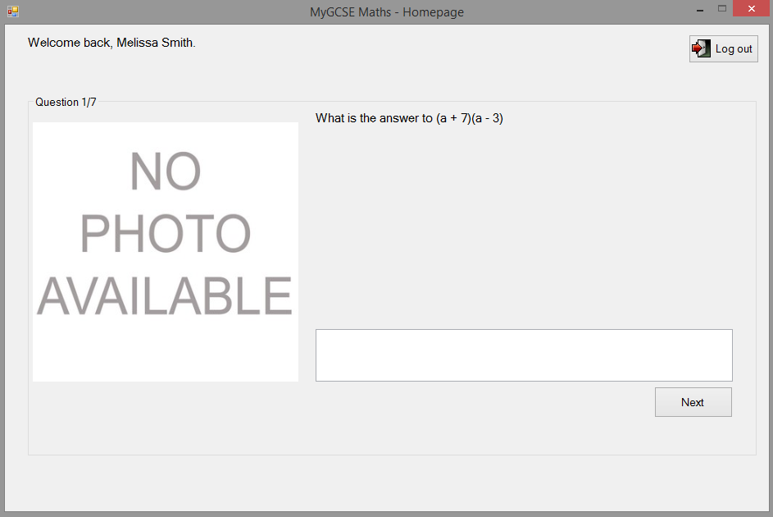

Samples of screen display

This is the teachers form (class tab) –Here teachers can search for students that have been assigned to their class, and click on a student’s picture in order to view their quiz progress.

The logout button is used when the user wants to logout of the system. It will close all current open forms and take the user back to the login page.

The search field and search button is used when a teacher wants to find pupils in their class. The teacher would search for a name and click the search button. The system will then display all the users found in the panel below.

This label shows the amount of students currently being displayed on the square panel below.

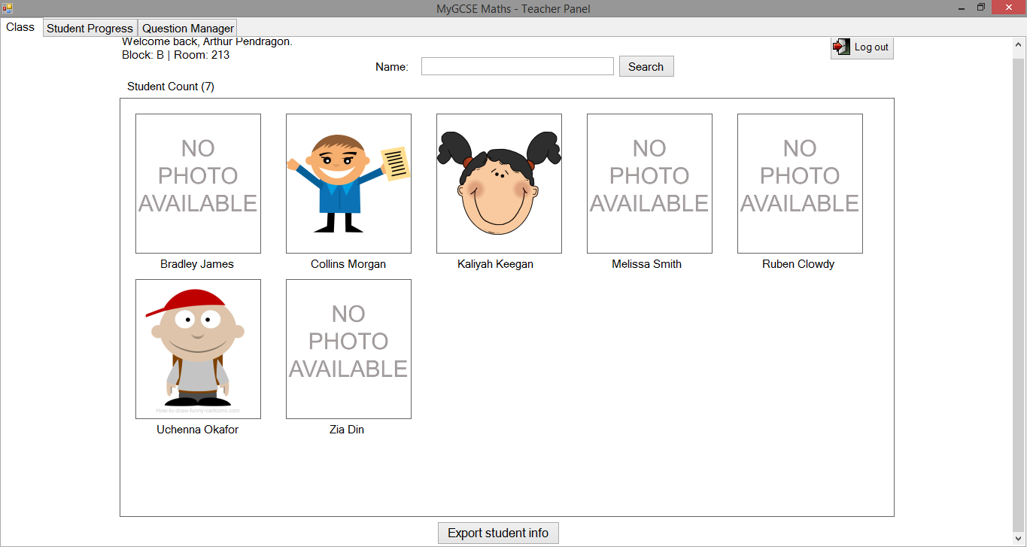

The “export student info” button is used when the teacher wants to export a .txt file containing the “MyGCSE Maths” account credentials of each student in their class. This button will prompt a Dialog which is used to select a save location.

When the teacher clicks a picture box of a student. It will take them to the Student Progress tab page whereby the teacher can see the progress of the student they clicked on.

This is the Teacher form (student progress tab) – In this tab teachers are able to view student quiz progress and export a report of students quiz performance

When either values of the two date pickers are changed, the graph is automatically updated to display the student results that match the date range. If the date ranged from 01 Feb 2015 to 08 Feb 2015, the program will display the results of all the quizzes the specific student had completed from that data range.

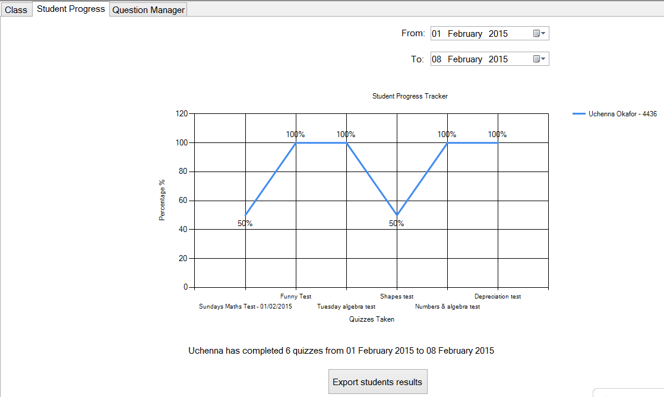

The “export student’s results” button will prompt a dialog box which will export a report of each student’s overall quiz performances to a .txt file. The text file will contain the students’ full name, the total amount of quizzes they had completed and the average percentage of quizzes taken.

The file would look like the box on the right.

This report would be produced for each student that

has been assigned to the teachers class in order of

lowest to higher.

Uchenna Okafor

Total quizzes completed: 17

Average: 76%

This is the teachers form (question manager tab) *–* Here teachers can add, generate, view and delete questions. They can also set quizzes for students there.

The search button will display all the questions in the SQL database that match the criteria of the two drop down lists on the left. If the teacher only selects “B” as the topic, then all B questions will be displayed. If “B” and the Topic “Algebra” was selected, all B grade algebra questions will be displayed. If the teacher leaves the drop down lists as default, then it will shows all questions in the database.

The generate question button will open a form whereby the teacher can use to generate questions. The teacher fills in a criteria, clicks generate and the system will generated the questions and add them to the SQL database automatically.

This button is for adding a question manually.

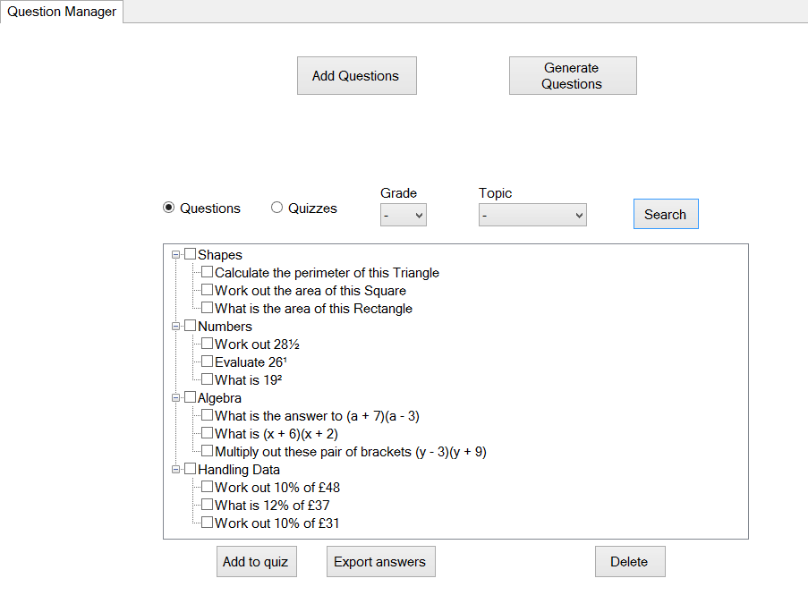

The “add to quiz button” will take each selected question from the tree view of questions and add each question to a new quiz.

The “export answers” button will export the question and answer of each selected question from the tree view to a .txt file. This is to export mark schemes.

The delete button is used to delete all selected questions.

This is the teachers form -> Add question form – This is a multi-purpose form that teachers can use to either add a question, or edit an existing question.

This text box is where the text of the question you want to be shown is entered.

Clicking the picture box will allow you to import an image for the question.

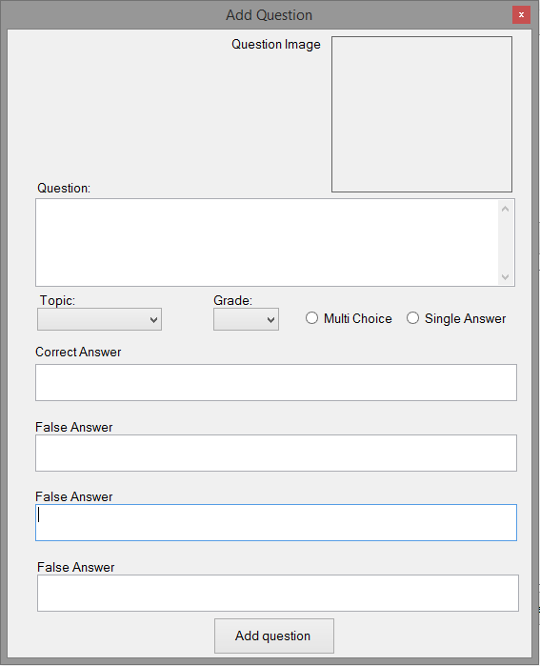

These textboxes are used to enter the correct answer of a question if the single choice option is selected, and false answers if the multiple choice options is selected.

These controls are used to define a question. Using the drop down lists you can set the Topic and grade difficulty of the question. Using the radio buttons you can select whether the question is a multiple choice question or single answer questions.

This button will then process all the data entered into the form and add the question to the SQL database.

This is the teachers form -> question generator form *–* This form is used to generate questions. The generate questions is then automatically added to the SQL database. Once in the SQL database, teachers can add the questions to quizzes for students to complete.

This is the grade difficulty of question. The values range from A, B, C, D and E.

Used to select the topic of the generated questions.

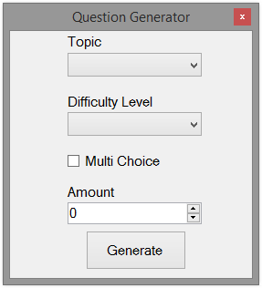

This check box is used to indicate if the questions are to be multiple choice questions or single answer questions.

Used to select the amount of questions to be generated.

Once the criteria of the form is filled in and the generate button is clicked, the system will process the request and generate the amount of questions requested depending on the criteria specified.

This is the admin form– Here the admin can create new account, create new classes (on the class tab) and search for users.

The search field and search button is used to search for users. The name of the user to be searched for is entered in the search box, when the search button is clicked, the system will display a list of all the users found.

The logout button is used when the admin wants to logout of the system. Clicking it will close all open forms and return to the login page.

Clicking the rectangular picture box allows you to import an image for the new user.

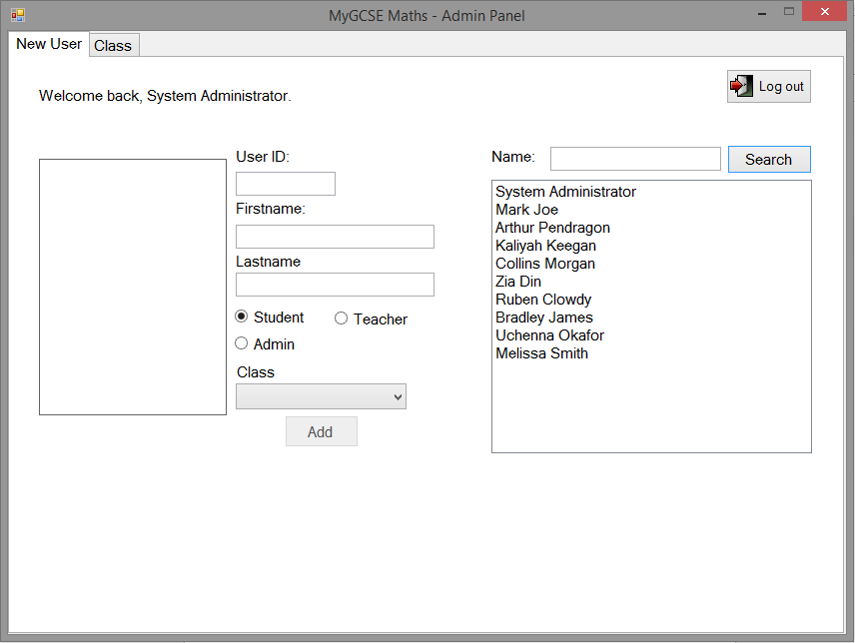

Used to add the users credentials to the system.

Used to assign the rank of the user.

Used to assign users to a class. Only teachers and students can be allocated to a class, admins can’t.

This form is the edit form. This form is part of the admin form and is called when the admin wants to edit or delete a user’s credentials.

This picture box is used to display the user’s picture, when clicked it allows you to select a new picture for the user.

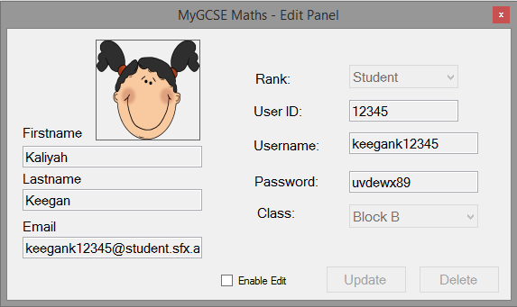

Enabling the check box will enable all the controls for edit. If the enable edit button is unchecked, it will disable all textboxes and buttons, this is to prevent the admin from accidentally changing the details of a user. They must enable edit before they are able to change the details of the user.

Clicking this will edit the users previous account information with the one currently entered in the form.

This combo box is used to change the class the teacher or student is allocated to.

Used to delete the users account.

Sample error messages and recovery procedures.

Duplicate UserID error:

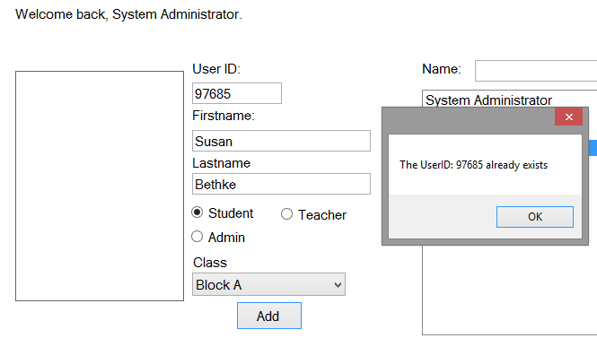

If an admin tries to add a user with a UserID that already exists, the system will throw an error message saying that the UserID already exists and that it already belongs to another user. **To fix this, make sure each user entered has a unique user id.**

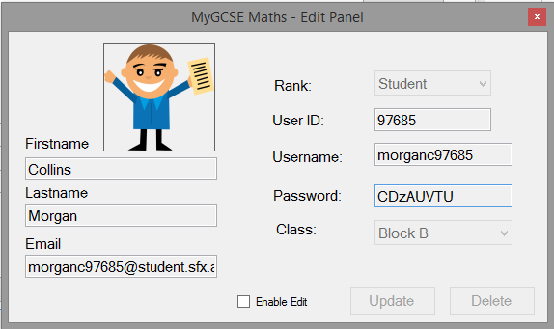

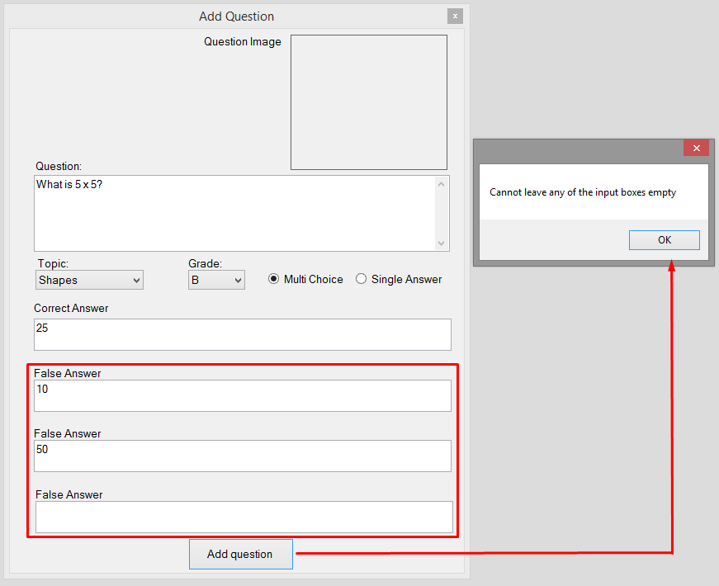Adding question error:

When trying to add a new question, if multiple choice is the selected question type then all the multiple choice textboxes must be filled in. If they’re not filled in, an error message will be displayed, therefore the system will not add the question.

**To fix this, just fil in all the data required.**

Not selecting a question to manipulate error:

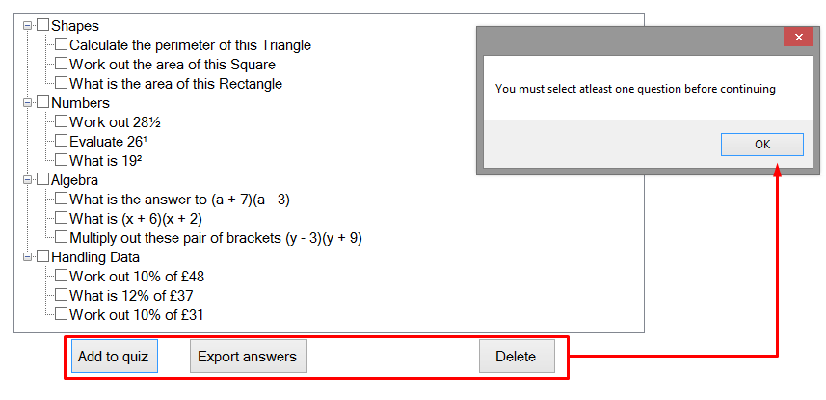

If the user (teacher) wants to create a quiz, export answers or delete questions, then they must select at least one question from the tree view. If no items are selected an error message will be displayed.

**To fix this error, ensure at least one item is selected from the tree view before creating a new quiz, exporting answers or deleting questions.**

`

Question generator error:

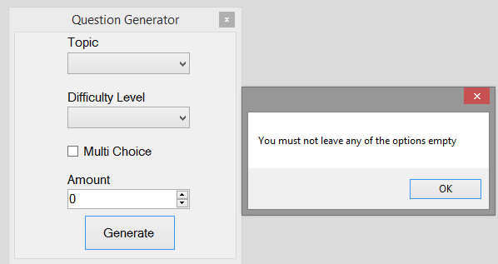

To generate questions, the user must fill in all options in the question generator form before you press the generate question button. If you do not an error message will display saying that you must not leave any option empty. To fix this error, ensure that all options have not been left empty before clicking the generate button.

Adding a new class error:

When the admin wants to add a new classroom. If the block or room textbox is empty the system will display an error message. **To fix this just make sure the data is entered in the two text boxes.**

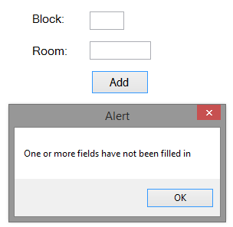

Export student info error:

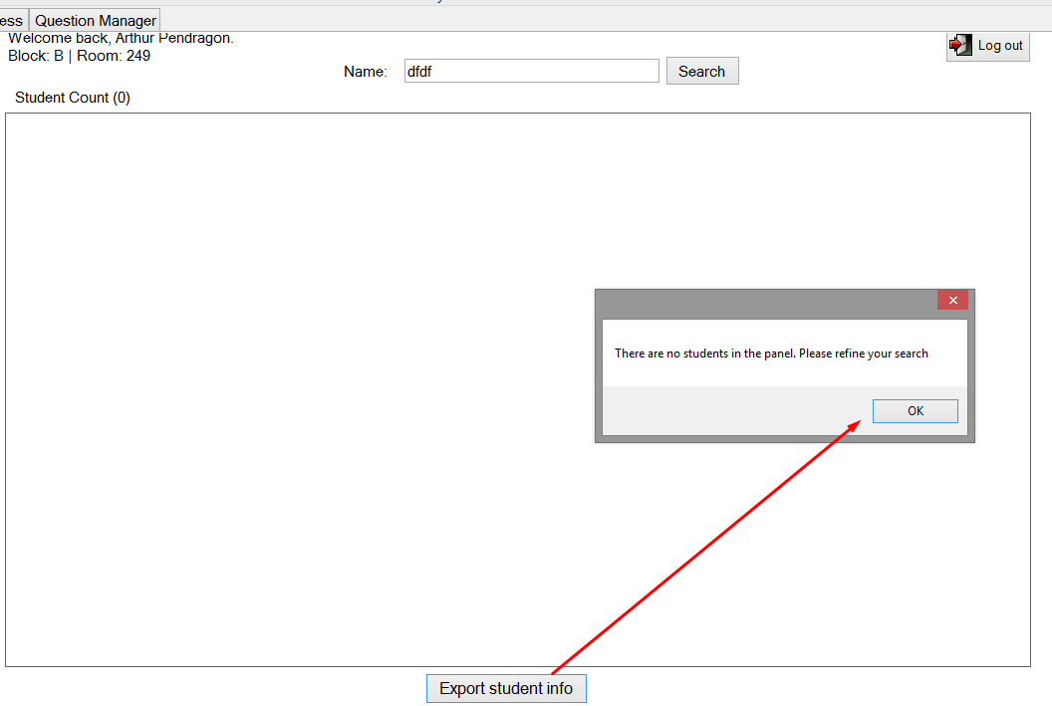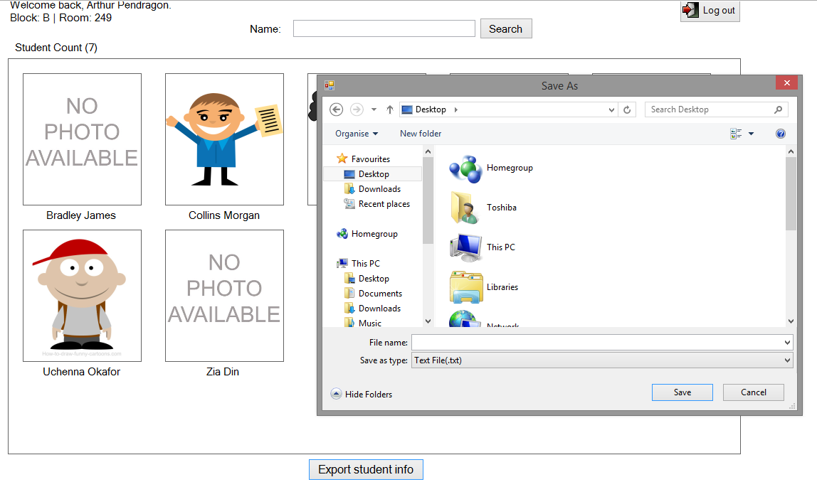

If the students need to export students MyGCSE maths account credentials and there is no student currently visible in the rectangle panel then the system will throw an error message.

**To fix this, make sure there’s at least on student showing in the panel below**